Tracing The Growth Of The Global Community A Population Forecasting Analysis :

**Description:**

The world’s population is more than three times larger than it was in the mid-twentieth century.The global human population reached 8.0 billion in mid-November 2022 from an estimated 2.5 billion people in 1950, adding 1 billion people since 2010 and 2 billion since 1998. The world’spopulation is expected to increase by nearly 2 billion persons in the next 30 years, from thecurrent 8 billion to 9.7 billion in 2050 and could peak at nearly 10.4 billion in the mid-2080s.This dramatic growth has been driven largely by increasing numbers of people surviving to reproductive age, the gradual increase in human lifespan, increasing urbanization, and accelerating migration. Major changes in fertility rate have accompanied this growth. These trends will have far-reaching implications for generations to come.

**Business requirements :**

## **The population of the world today**

The world population increased from 1 billion in 1800 to around 8 billion today.

The world population growth rate declined from around 2% per year 50 years ago to under 1.0% per year.

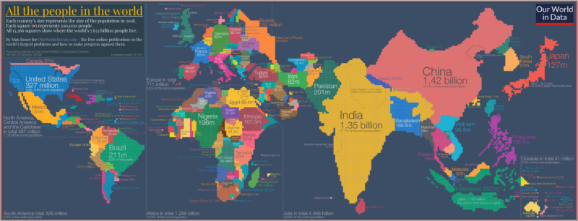

One way to understand the distribution of people across the world is to reform the world map, not based on the area but according to population.

This is shown here in a population cartogram: a geographical presentation of the world where the size of the countries is not drawn according to the distribution of land, but according to the distribution of people. The cartogram shows where in the world the global population was at home in 2018.

The cartogram is made up of squares, each of which represents half a million people of a country’s population. The 11.5 million Belgians are represented by 23 squares; the 49.5 million Colombians are represented by 99 squares; the 1.415 billion people in China are represented by 2830 squares, and the entire world population of 7.633 billion people in 2018 is represented by the total sum of 15,266 squares.

As the size of the population rather than the size of the territory is shown in this map you can see some big differences when you compare it to the standard geographical map we’re most familiar with. Small countries with a high [population density](https://ourworldindata.org/grapher/population-density) increase in size in this cartogram relative to the world maps we are used to – look at Bangladesh, Taiwan, or the Netherlands. Large countries with a small population shrink in size (look for Canada, Mongolia, Australia, or Russia).

**THE NEED FOR FORECASTING POPULATION :**

In the solution of any planning problem, the planner either makes an explicit forecast, or makes some implicit assumption about the population for which he is planning. "Population" includes much more than mere numbers of people. The planner must know what kind of people live in his planning area, what types of lives they lead, and would like to lead, how long they will live, and how long they will reside in the particular area; and who will replace them when they move out or die; how many children they will have (and would like to have under different conditions), whether these children will live in the area, and many other factors.

Many communities have installed facilities which have become useless because predicated on faulty estimates of future population, or they have failed to install facilities where justified by future population. A common example of such errors is the newly constructed school in an area where the population is aging rather than being replaced by young, child-bearing families. Sewer systems have been expensively developed only to be later replaced because the population soon was double or triple what was anticipated for the area. Narrow streets have been later widened at great expense. On the other hand, land often has been overly zoned for commercial purposes in the expectation of a vast increase in population which did not materialize. Or land was zoned for potential capacities in some cities of whole state or even the entire population of the country. Prematurely subdivided land is plaguing many of our communities today.

Population growth is the increase in the number of people in a population or dispersed group. Actual global human population growth amounts to around 83 million annually, or 1.1% per year. The global population has grown from 1 billion in 1800 to 7.9 billion in 2020. The UN projected population to keep growing, and estimates have put the total population at 8.6 billion by mid-2030, 9.8 billion by mid-2050 and 11.2 billion by 2100. However, some academics outside the UN have increasingly developed human population models that account for additional downward pressures on population growth; in such a scenario population would peak before 2100.

Absolute increase in global human population per year

World human population has been growing since the end of the Black Death, around the year 1350. A mix of technological advancement that improved agricultural productivity and sanitation and medical advancement that reduced mortality increased population growth. In some geographies, this has slowed through the process called the demographic transition, where many nations with high standards of living have seen a significant slowing of population growth. This is in direct contrast with less developed contexts, where population growth is still happening.Globally, the rate of population growth has declined from a peak of 2.2% per year in 1963. The global human population is projected to peak during the mid-21st century and decline by 2100.

Human population growth and the demographic transition

The world and most regions and countries are experiencing unprecedentedly rapid demographic change. The most obvious example of this change is the huge expansion of human numbers: four billion have been added since 1950. Projections for the next half century expect a highly divergent world, with stagnation or potential decline in parts of the developed world and continued rapid growth in the least developed regions. Other demographic processes are also undergoing extraordinary change: women's fertility has dropped rapidly and life expectancy has risen to new highs. Past trends in fertility and mortality have led to very young populations in high fertility countries in the developing world and to increasingly older populations in the developed world. Contemporary societies are now at very different stages of their demographic transitions. This paper summarizes key trends in population size, fertility and mortality, and age structures during these transitions. The focus is on the century from 1950 to 2050, which covers the period of most rapid global demographic transformation.

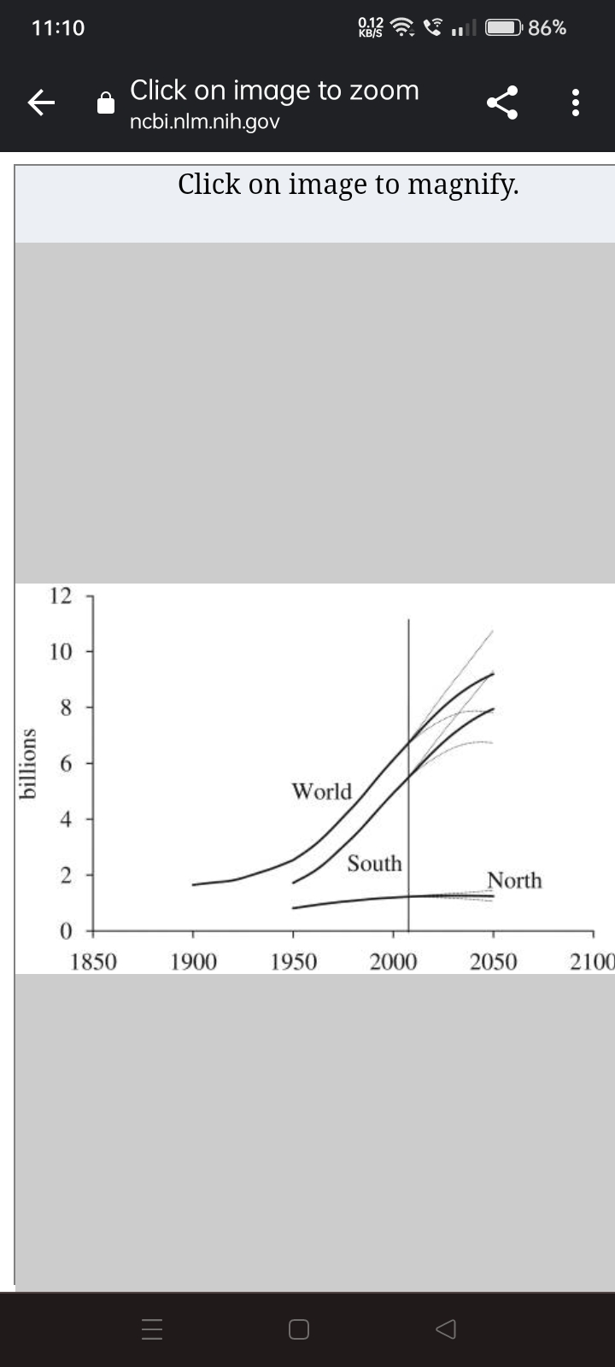

Contemporary societies are at very different stages of their demographic transitions. Key trends in population size, fertility and mortality during these transitions are summarized below. The focus is on the century from 1950 to 2050, covering the period of most rapid global demographic change. The main source of data is the United Nation's 2006 world population assessment, which provides estimates for 1950–2005 and projections from 2005 to 2050

The world and most countries are going through a period of unprecedentedly rapid demographic change. The most obvious example of this change is the huge expansion of human numbers: four billion have been added since 1950. Other demographic processes are also experiencing extraordinary change: women are having fewer births and LEs have risen to new highs. Past trends in fertility and/or mortality have led to very young populations in high fertility countries in the South and to increasingly older populations in the North. Still other important demographic changes which were not reviewed here include rapid urbanization, international migration, and changes in family and household structure.

Global population growth will continue for decades, reaching around 9.2 billion in 2050 and peaking still higher later in the century. The demographic drivers of this growth are high fertility in parts of the South, as well as declining mortality and momentum. This large expansion in human numbers and of the accompanying changes in the age structure will have multiple consequences for society, the economy and the environment as discussed in the subsequent chapters in this issue.

Data integration:

Data integration is the process of combining data from multiple source systems to create unified sets of information for both operational and analytical uses. It's one of the core elements of the overall data management process -- the main objective of data integration is to produce consolidated data sets that are clean and consistent and meet the information needs of different end users in an organization.

Integrated data is fed into transaction processing systems to drive business applications and into data warehouses and data lakes to support business intelligence (BI), enterprise reporting and advanced analytics. Various data integration methods have been developed for different types of uses, including batch integration jobs run at scheduled intervals and real-time integration done on a continuous basis.

Strategic decision making:

Data driven decision making (DDDM) is the process of using data to make informed and verified decisions to drive business growth. By using the right KPIs and tools, companies can overcome biases and make the best managerial rulings that are aligned with their strategies.

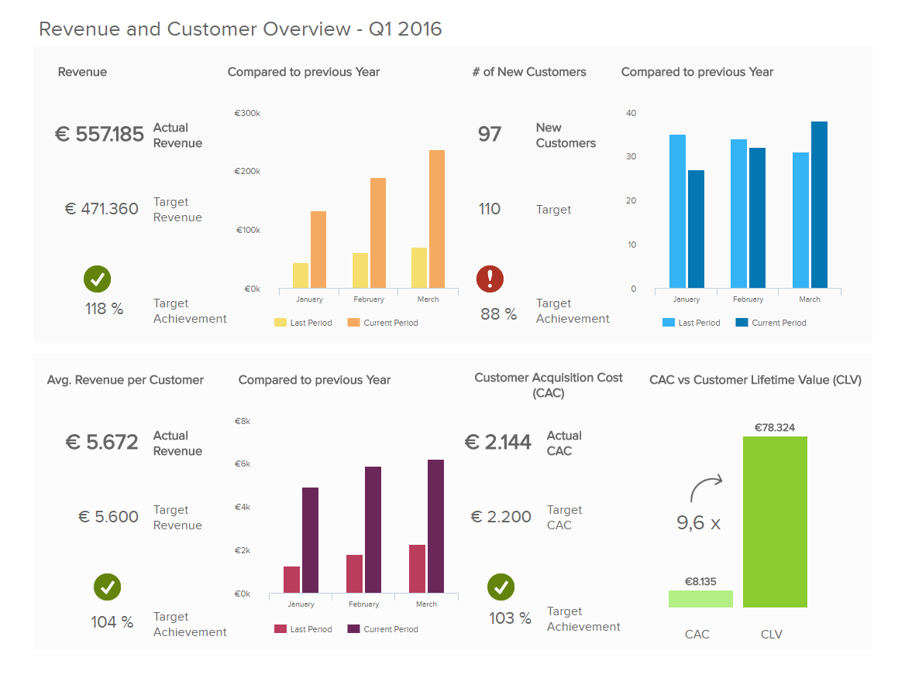

Fundamentally ,using data for decision making means working towards key business goals by lever aging verified, analyzed information rather than merely shooting in the dark.

However ,to extract genuine value from your information, it must be accurate as well as relevant to your aims. Collecting, extracting, formatting, and analyzing insights for enhanced data driven decision making in business was once an all-encompassing task ,which naturally delayed the entire data decision making process.

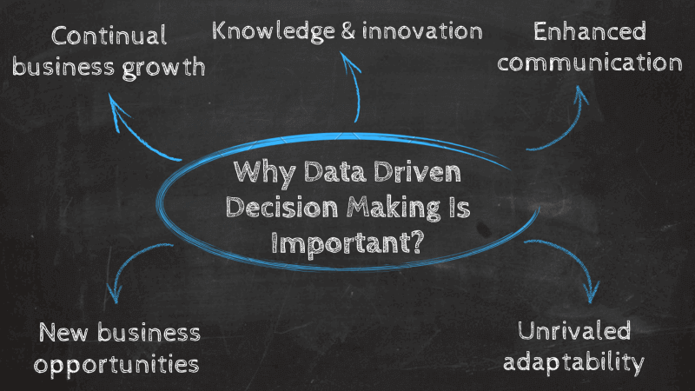

Data based decision making provides businesses with the capabilities to generate real time insights and predictions to optimize their performance. Through this, they can test the success of different strategies and make informed business decisions for sustainable growth.